Process Flow :Time Master Import

Step 1:

- Please Select Time Master option from BIS Menu.

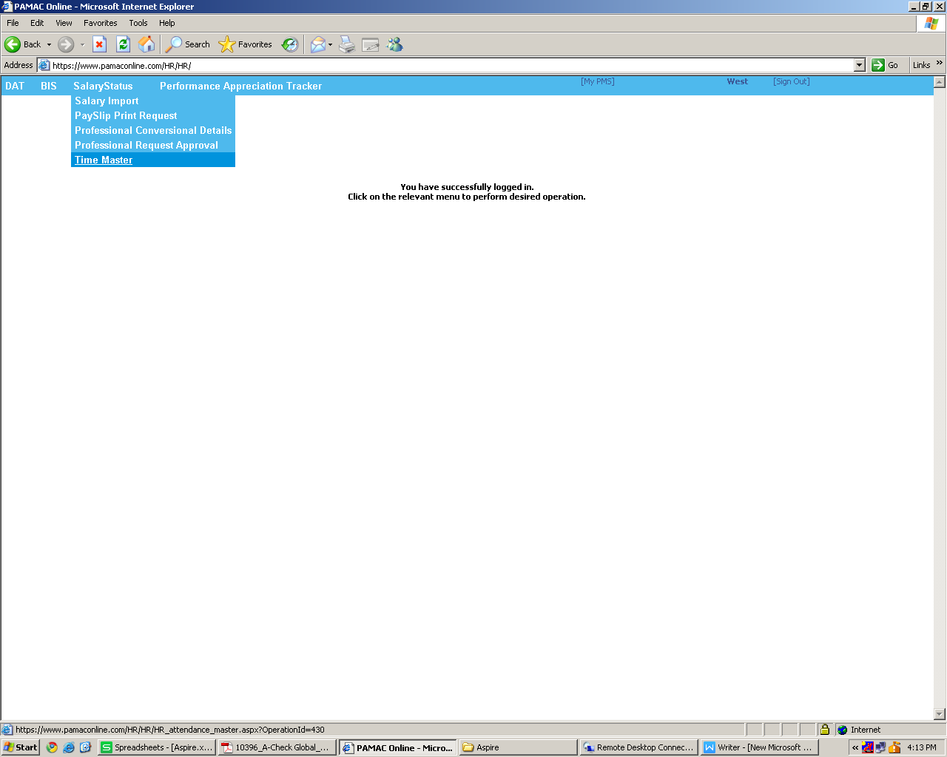

Step 2:

- Select Xls File and Click on Import option.
